Working of Marker based AR APP using Vuforia Engine and Unity ( By G Bhanuteja )

Steps:-

1. Login into Vuforia Developer Portal then in License Manager create a license.

2. Then in Target Manager, add an Image which will serve as an Image Target for augmenting the Coronavirus model on top of the image target.

( Ensure that the rating that Vuforia generates after adding that image is more than 3 or 4 stars so that model can be augmented properly )

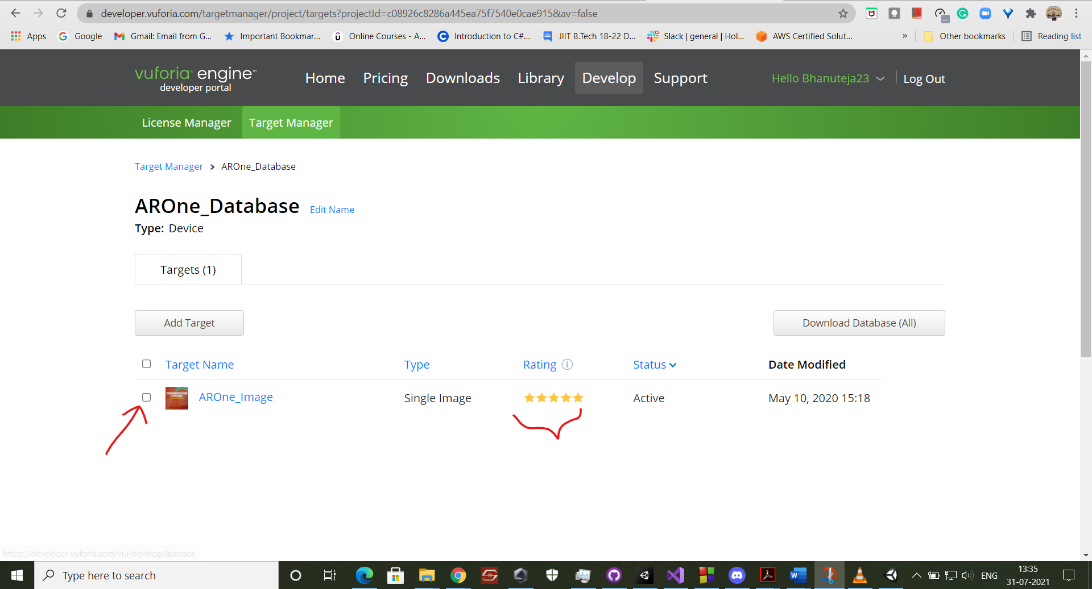

3. Then open Unity Engine, right click on Hierarchy, then in Vuforia Engine choose ARCamera, this will add the ARCamera to Unity scene.

4. Then right click on ARCamera and then choose Image from Vuforia Engine drop down menu which will act as an Image Target.

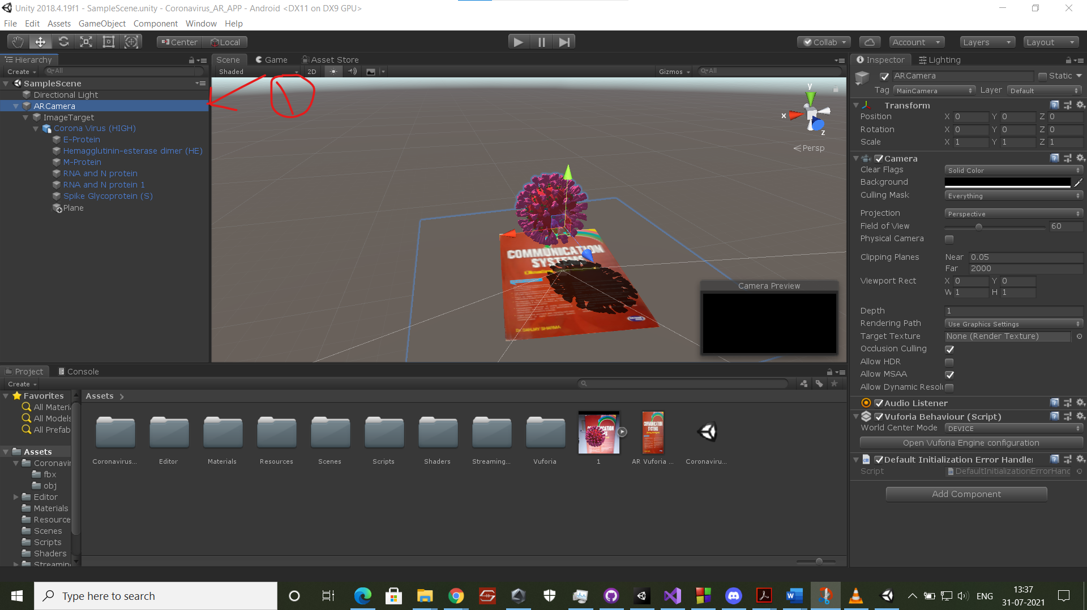

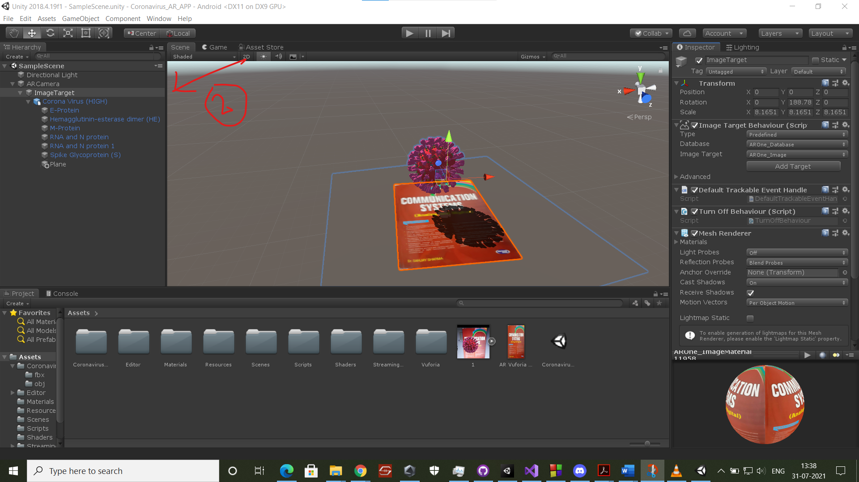

5. Then drag and drop the 3D model which you want to augmented under Image Target and move the 3D model a little upwards so that when it gets augmented on top of this Image Target it doesn’t stick to the target and stay a little top on it.

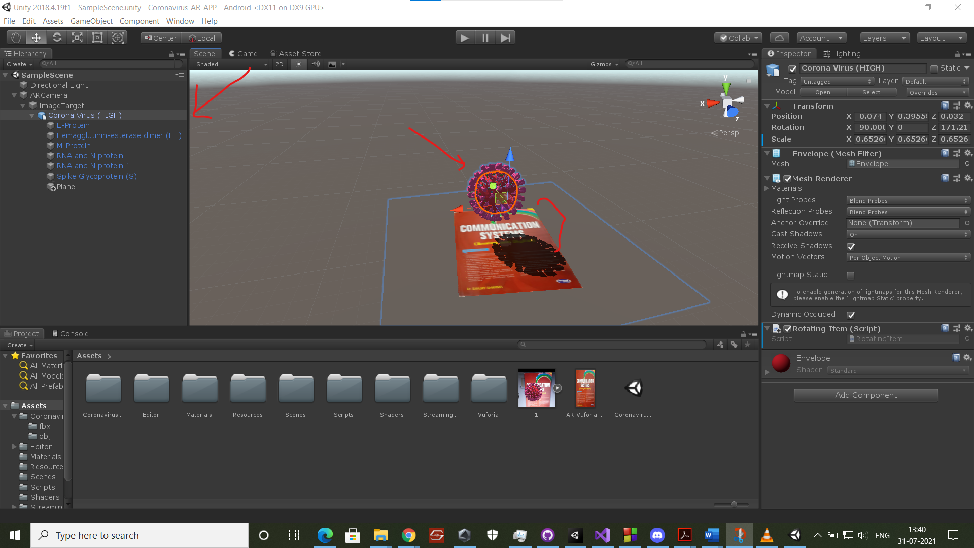

6. Now we have to configure Vuforia Engine inside Unity so that it’s able to augment the model on top of the Image Target.

(i) We have to copy the license key which gets generated in License Manager on Vuforia Developer Portal.

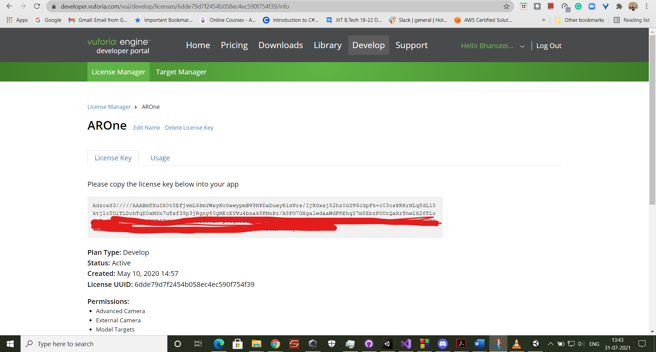

(Removed a portion of License Key for safety reasons)

(ii) Then open Vuforia Engine Configuration by clicking on ARCamera then in inspector you will find an option

Open Vuforia Engine Configuration. Click on that

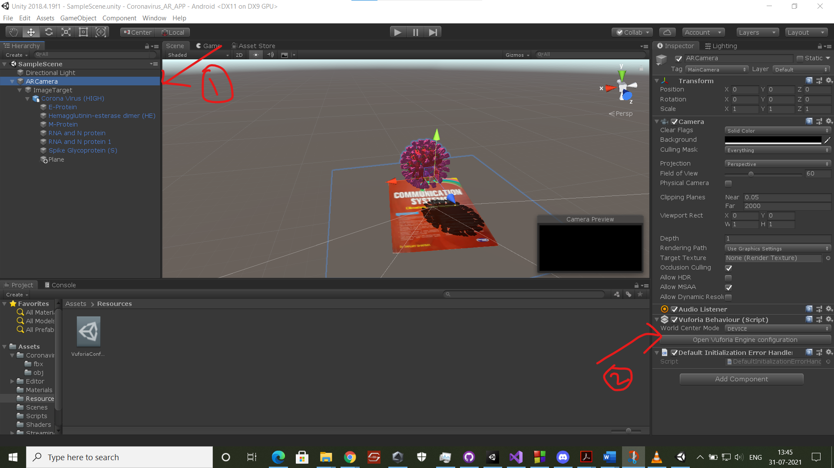

(iii) Now paste the copied License key in APP License Key section in inspector.

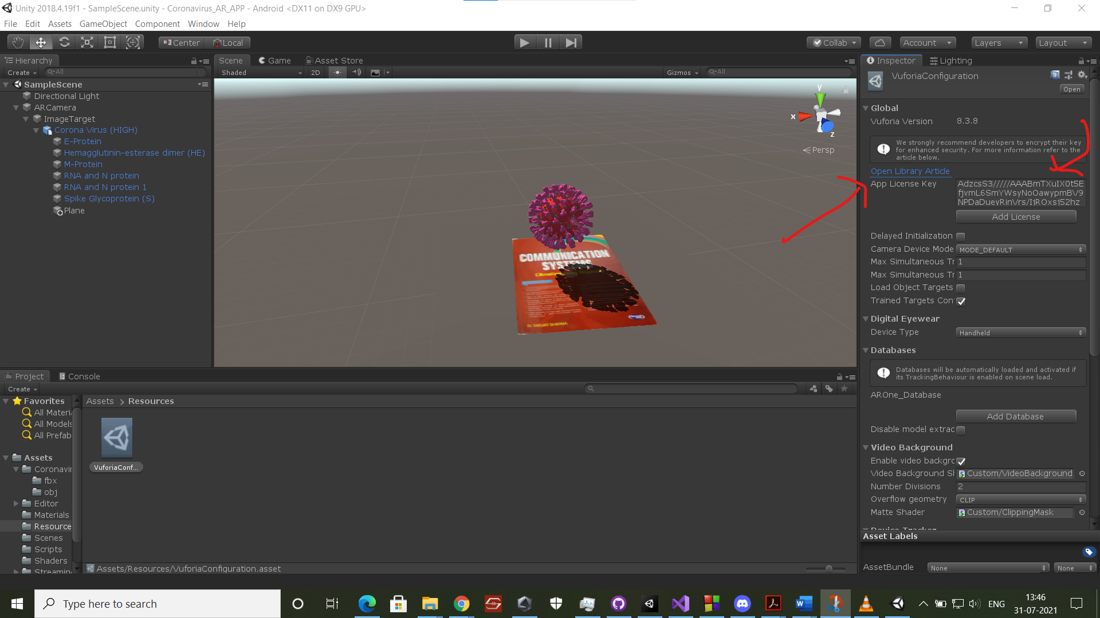

(iv) Now choose your webcam from this option so that model gets augmented while using Webcam on your PC in Unity Engine:-

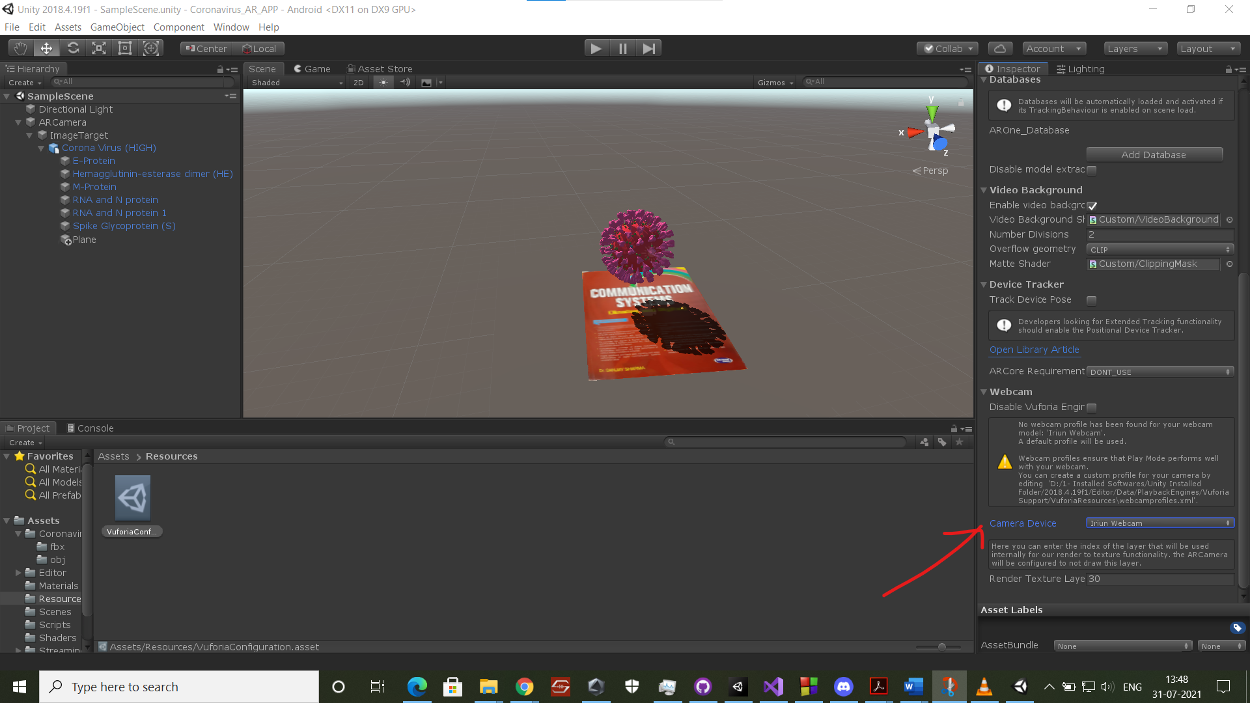

7. That’s all required for configuring Vuforia in Unity Engine. Now switch the platform to Android in build settings in Unity if not already switched. Then build the APK.

8. Now test the built APK in an Android device using this Image Target:-

<https://github.com/gbhanuteja23/Coronavirus_AR_APP/blob/master/Assets/AR%20Vuforia%20Image%20Target_1.jpg>

(Download this Image target on a different phone and place the opened APK on it, you can see that a coronavirus model gets augmented on top of the image target and it’s rotating on it’s axis)

Working Video of Project:-

<https://youtu.be/2hz4NvqLyTc>

Pictures of Working:-

